Get responses tailored to you
Log in to get answers based on saved chats, plus create images and upload files.
Log in
Caravan Camping Setup at Liwa Festival – Powered by Remal Camper Rental
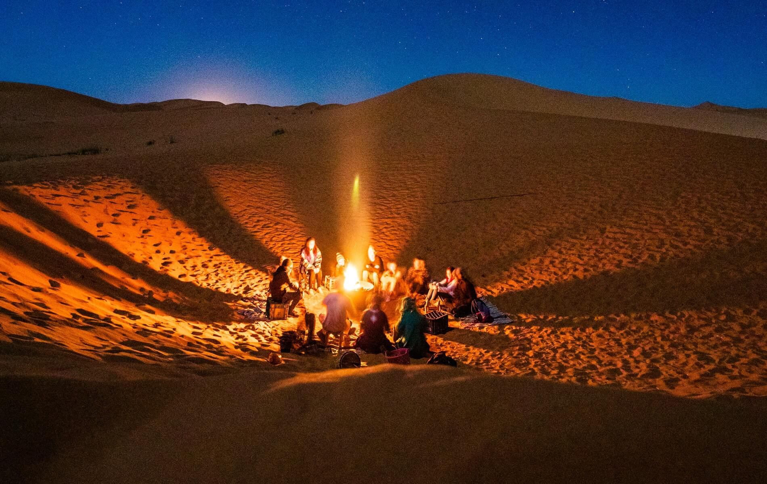
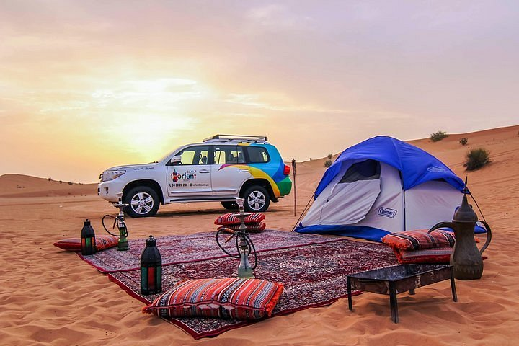
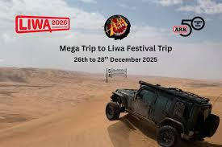
4
Every year, the Liwa desert transforms into a vibrant hub of culture, adventure, and outdoor living during the Liwa Festival. For camping enthusiasts, this is one of the best opportunities in the UAE to experience desert life in comfort—especially with a fully equipped caravan or motorhome from Remal Camper Rental.

🚐 Premium Camping Options by Remal Camper Rental
🔹 Iveco Motorhome – Luxury in the Desert

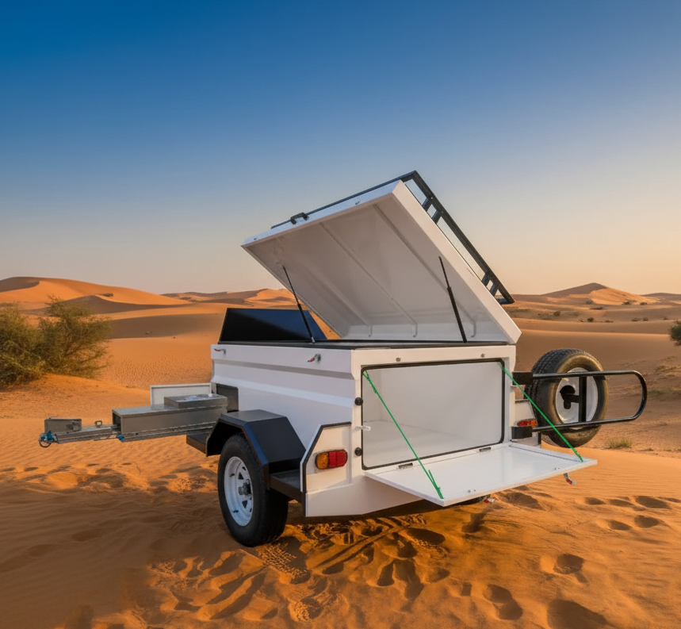
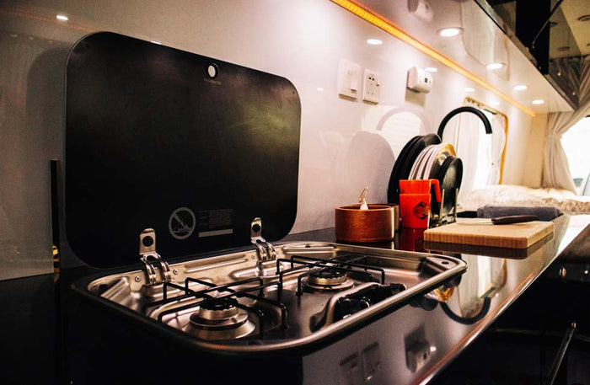
4
The Iveco motorhome brings hotel-like comfort to the middle of the desert. Ideal for families and long stays at Liwa Festival, it includes:
- Fully equipped kitchen and fridge
- Comfortable sleeping area with AC
- Outdoor awning with seating setup
- Storage for BBQ gear and camping essentials

🔹 Ram 4WD Popup Camper – Adventure Meets Simplicity
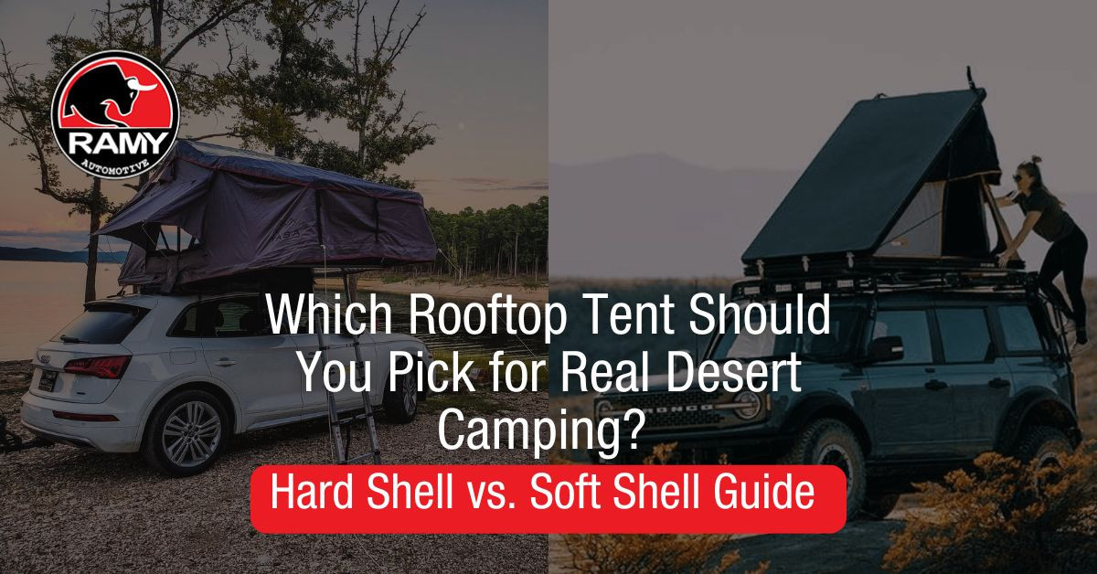

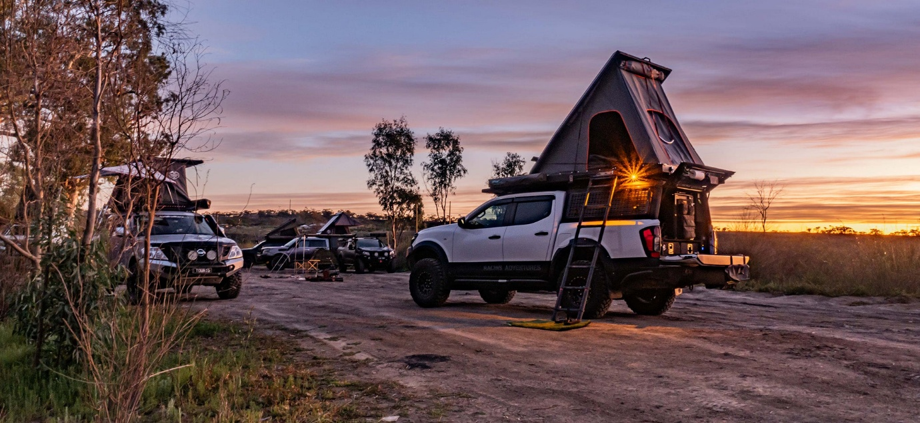
4
For off-road lovers, the Ram popup camper is built to explore deep into the dunes. It’s compact, powerful, and ideal for adventurous campers.
- Rooftop popup sleeping system
- Off-road capability for dune access
- Quick setup with camping chairs & table
- Portable cooking and BBQ equipment

👨‍👩‍👧‍👦 Family Popup Truck Camping Experience
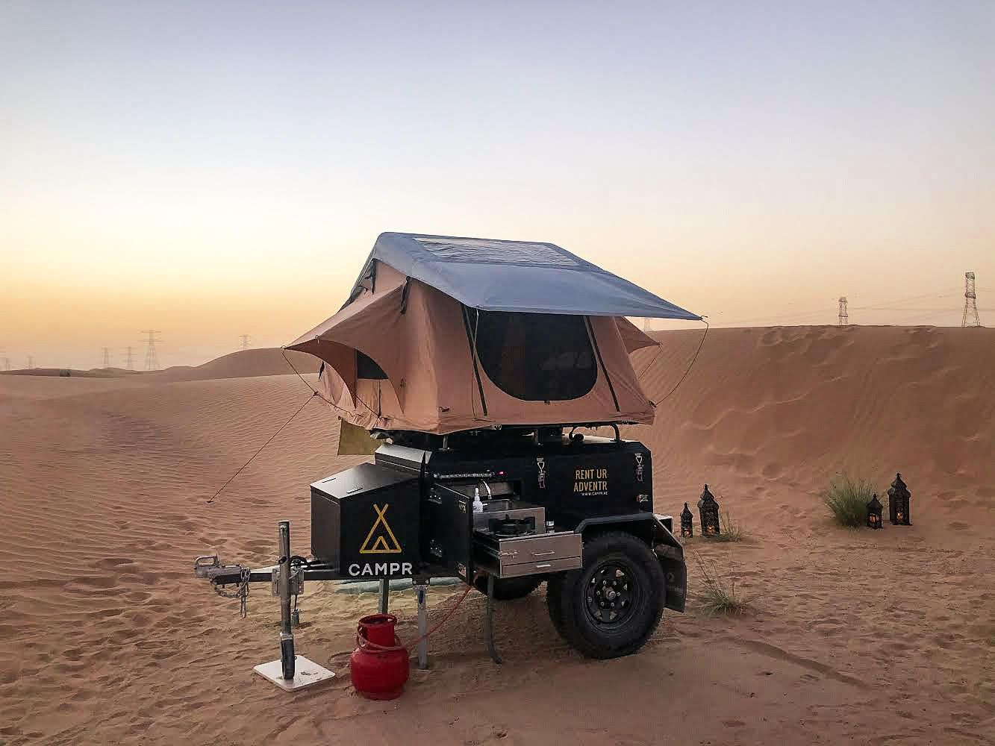
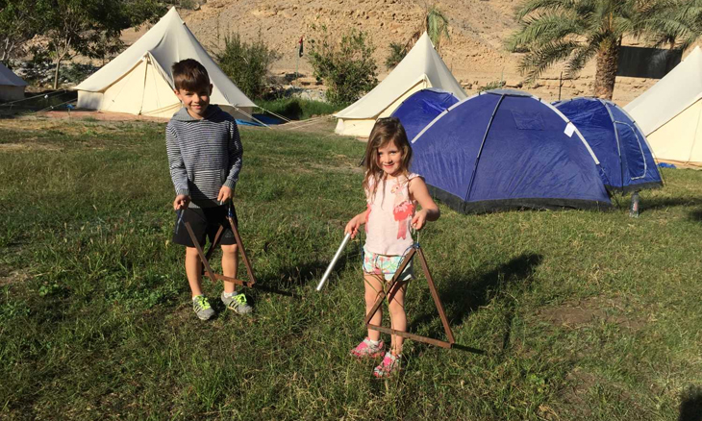

4
One of the highlights of Liwa Festival camping is the family-friendly atmosphere. Popup truck campers from Remal Camper Rental are perfect for creating memorable family moments:
- Kids enjoying open desert space safely
- Family BBQ dinners under the stars
- Rooftop sleeping adventure for children
- Cozy campfire gatherings at night
These setups bring families closer to nature while maintaining comfort and safety.

🔥 Complete Desert Camping Setup
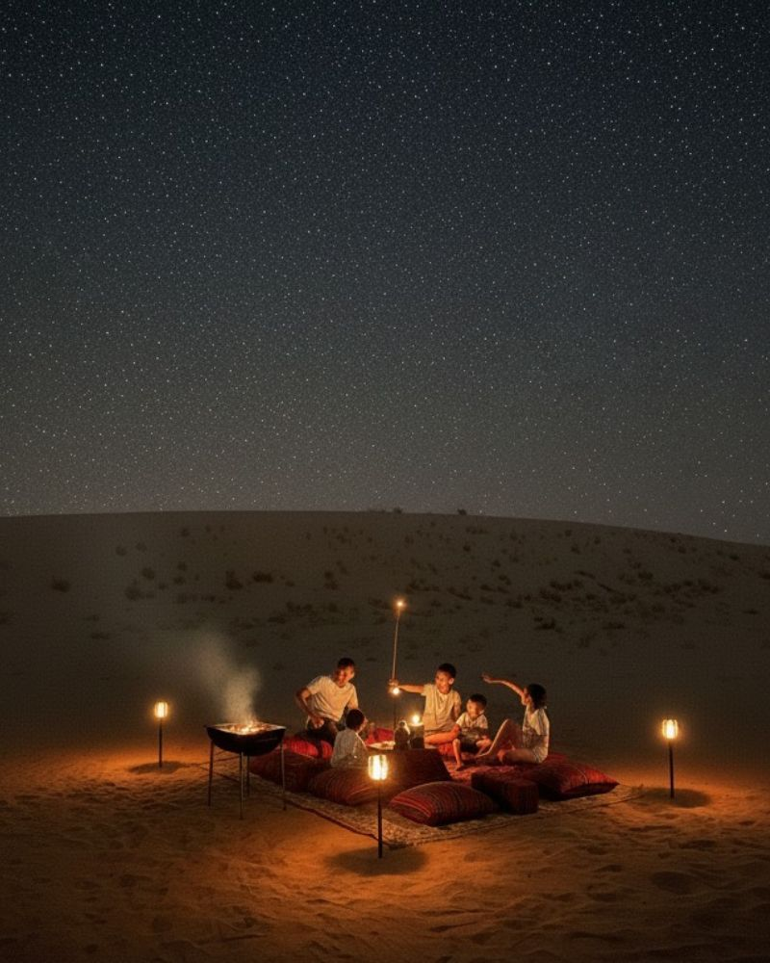
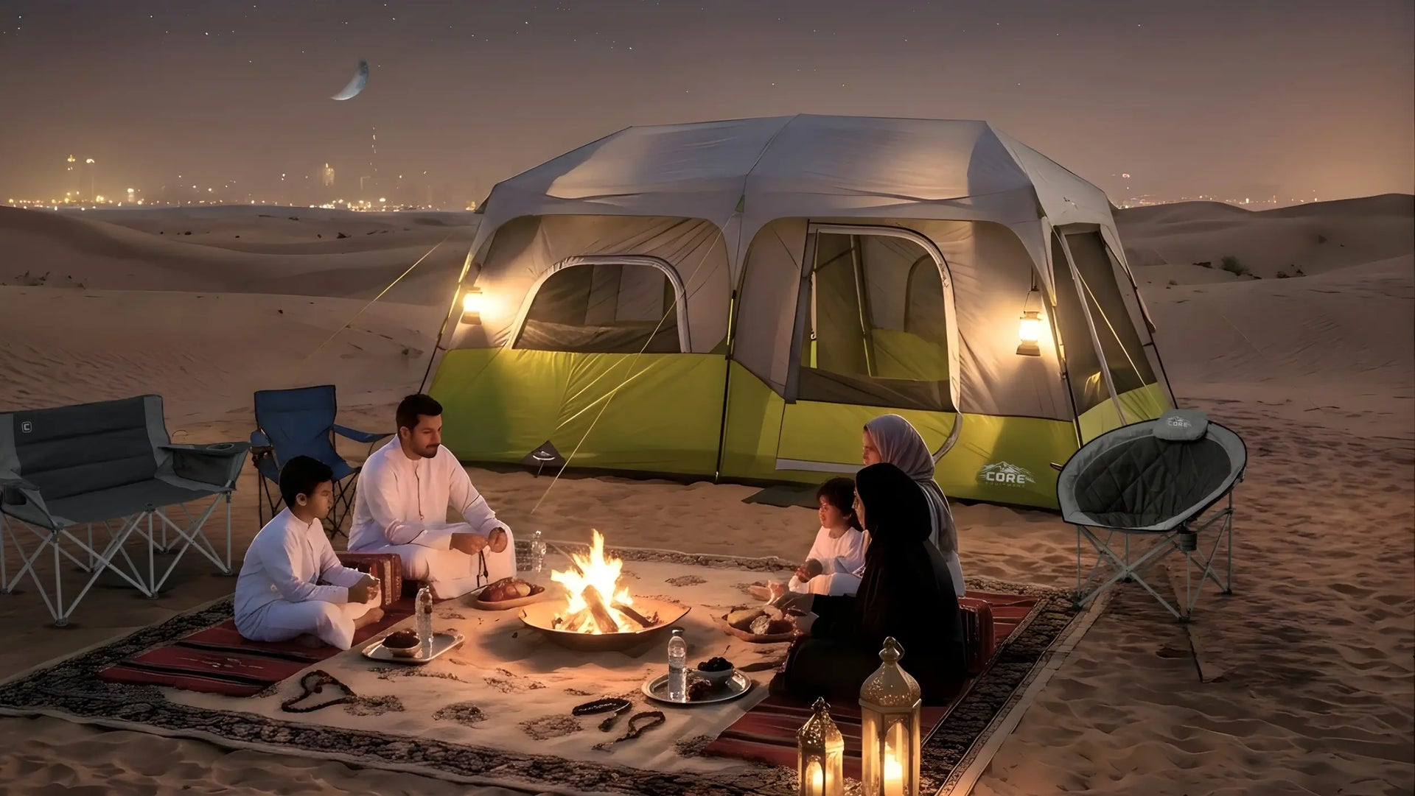
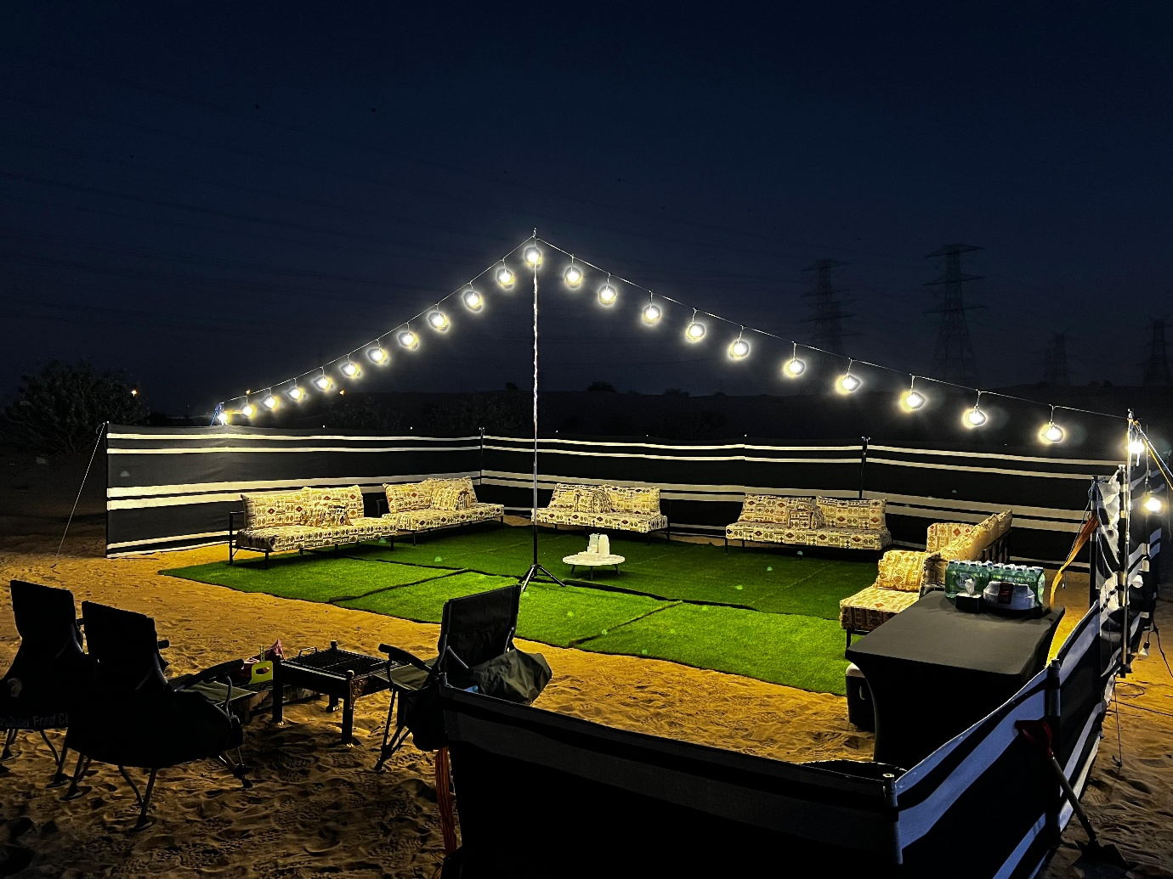
4
A typical Remal camping setup at Liwa Festival includes everything you need:
- Shaded seating area with carpets and cushions
- BBQ grill and cooking station
- Fire pit for warmth and ambiance
- LED lights for a cozy night setup
- Safe play area for kids

🌅 Why Liwa Festival is Perfect for Caravan Camping
- Massive desert space for motorhomes and 4WD campers
- Exciting festival events and activities nearby
- Safe, family-oriented camping environment
- Stunning dune landscapes and sunsets

🚀 Plan Your Liwa Camping Experience
With Remal Camper Rental, your Liwa Festival trip becomes effortless. From Iveco motorhomes to Ram popup campers, every detail is designed for comfort, adventure, and unforgettable family memories.
Drive into the dunes, set up your camp, and enjoy Liwa like never before.

Voice

Caravan Camping Liwa Festival
You’re viewing user-generated content that may be unverified or unsafe.
Report
Caravan Camping Setup at Liwa Festival – Powered by Remal Camper Rental



4
Every year, the Liwa desert transforms into a vibrant hub of culture, adventure, and outdoor living during the Liwa Festival. For camping enthusiasts, this is one of the best opportunities in the UAE to experience desert life in comfort—especially with a fully equipped caravan or motorhome from Remal Camper Rental.

🚐 Premium Camping Options by Remal Camper Rental
🔹 Iveco Motorhome – Luxury in the Desert



4
The Iveco motorhome brings hotel-like comfort to the middle of the desert. Ideal for families and long stays at Liwa Festival, it includes:
- Fully equipped kitchen and fridge
- Comfortable sleeping area with AC
- Outdoor awning with seating setup
- Storage for BBQ gear and camping essentials

🔹 Ram 4WD Popup Camper – Adventure Meets Simplicity



4
For off-road lovers, the Ram popup camper is built to explore deep into the dunes. It’s compact, powerful, and ideal for adventurous campers.
- Rooftop popup sleeping system
- Off-road capability for dune access
- Quick setup with camping chairs & table
- Portable cooking and BBQ equipment

👨‍👩‍👧‍👦 Family Popup Truck Camping Experience



4
One of the highlights of Liwa Festival camping is the family-friendly atmosphere. Popup truck campers from Remal Camper Rental are perfect for creating memorable family moments:
- Kids enjoying open desert space safely
- Family BBQ dinners under the stars
- Rooftop sleeping adventure for children
- Cozy campfire gatherings at night
These setups bring families closer to nature while maintaining comfort and safety.

🔥 Complete Desert Camping Setup



4
A typical Remal camping setup at Liwa Festival includes everything you need:
- Shaded seating area with carpets and cushions
- BBQ grill and cooking station
- Fire pit for warmth and ambiance
- LED lights for a cozy night setup
- Safe play area for kids

🌅 Why Liwa Festival is Perfect for Caravan Camping
- Massive desert space for motorhomes and 4WD campers
- Exciting festival events and activities nearby
- Safe, family-oriented camping environment
- Stunning dune landscapes and sunsets

🚀 Plan Your Liwa Camping Experience
With Remal Camper Rental, your Liwa Festival trip becomes effortless. From Iveco motorhomes to Ram popup campers, every detail is designed for comfort, adventure, and unforgettable family memories.
Drive into the dunes, set up your camp, and enjoy Liwa like never before.

